Design and Testing documentation:
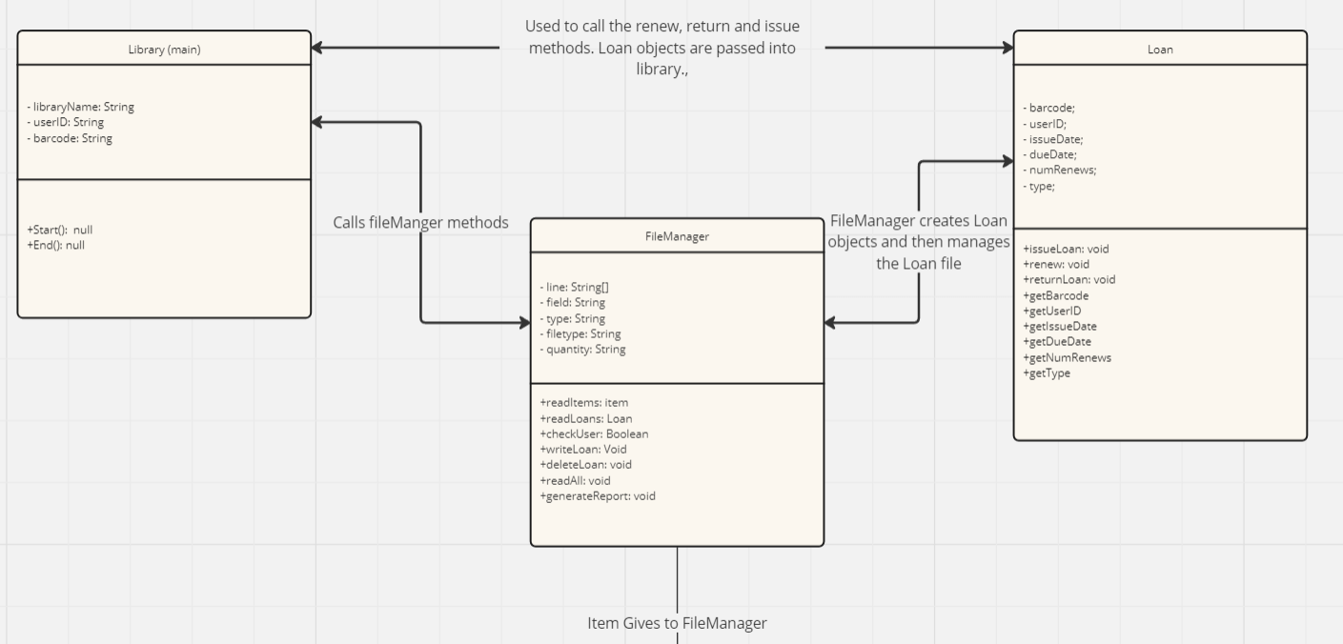
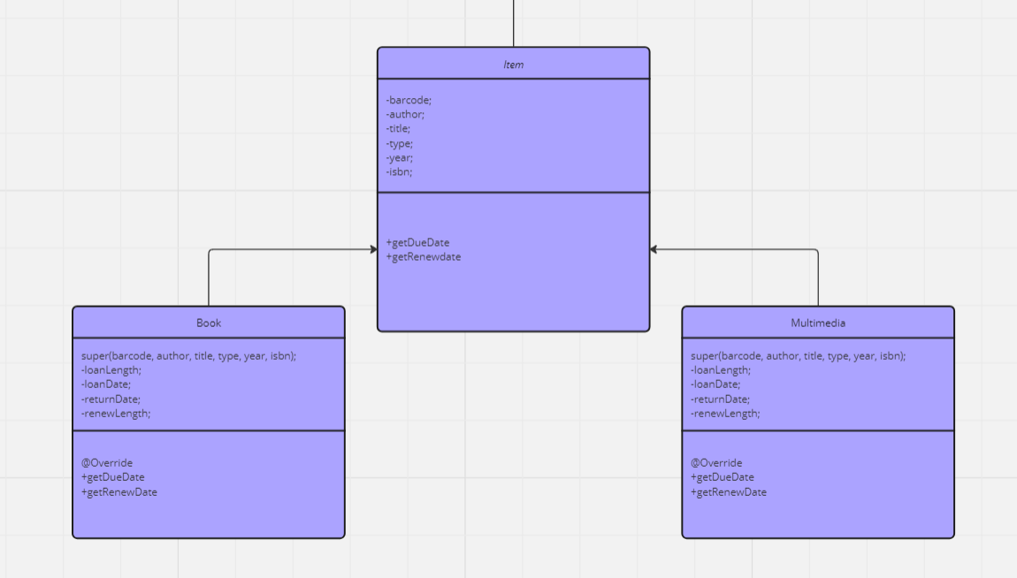

Overview
The structure of the UML diagram is to show the 6 classes and their relationship to each other. Library is the main class and calls methods from both Loan and FileManager which are both used to perform the various functions of the system. The FileManager class never makes any objects but instead is responsible for reading and writing files.

We use inheritance between item as the Superclass and Book and Multimedia as child classes in order to differentiate the loan and renew dates for these items. This only really comes into play when issuing a due Date as when renewing a loan we are working with a Loan object instead of an item. Since these Items data is being read by the file manager this is also where we create them before using return functions to pass them to the Library or Loan classes where the item object is either passed to other methods or the attributes are used to make a loan item.

FileManager
The choice behind the FileManager class was to help ensure the integrity of the files by only changing them in 1 class. This means that we will need to pass a lot of information to and from this class from both the library and Loan class and is why it is in the centre of our UML diagram. If we had file reading and writing in other functions, then it would mean that a lot of variables would be changing across classes as we fulfilled the user requirements. This would potentially cause errors and make our code harder to debug.

Book and multimedia
The choice to make book and multimedia into child objects came from wanting to simplify our usage of them. Although they aren’t as different as I first though this still helped when designing the issue and renew functions of our code. There was also a possibility of broadening this to include the Loan class. However, I didn’t feel as though there was a strong enough link that could be made and couldn’t think of a way to implement it that didn’t just serve to make the code more complicated than was necessary.

The Item class is an abstract class because we never want to make an item object. We do this so that we can call the superclass methods in item and then the code will use either the book or multimedia class methods depending on the item that has been passed into the function. This is our main use of both inheritance and polymorphism which saves us needing to compare item attributes to save in complexity. Without this we would need to use a method in the renewal class where we get and compare the type attribute and then independently calculate the renewal/ due date causing these parts of our code to become more complex and bloated.

Justification of attributes
The attributes we used were mostly given in the requirements document and so we didn’t need to add many. The use of polymorphism however would allow extra attributes to be added to either book or multimedia without heavily disrupting the already written code. These attributes could be page count or length. The most important attributes are barcode and userID as these are what is most used in almost all methods. Because of this we make them private to protect them from being accidentally changed by another method. The only other notable attribute was renew count which we had to parse to an integer when reading from a file so we could use it in logical comparisons when renewing items.

